

Yoga 101: Poses for Beginners
New to yoga? Try these basic yoga poses to get stronger and more flexible.
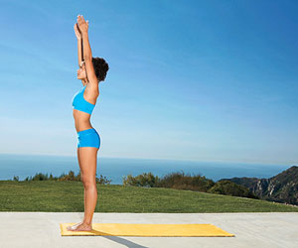Mountain Pose
- Stand tall with feet together, shoulders relaxed, weight evenly distributed through your soles, arms at sides.
- Take a deep breath and raise your hands overhead, palms facing each other with arms straight. Reach up toward the sky with your fingertips.
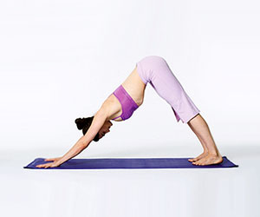Downward Dog
- Start on all fours with hands directly under shoulders, knees under hips.
- Walk hands a few inches forward and spread fingers wide, pressing palms into mat.
- Curl toes under and slowly press hips toward ceiling, bringing your body into an inverted V, pressing shoulders away from ears. Feet should be hip-width apart, knees slightly bent.
- Hold for 3 full breaths.
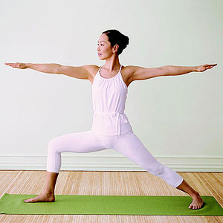Warrior
- Stand with legs 3 to 4 feet apart, turning right foot out 90 degrees and left foot in slightly.
- Bring your hands to your hips and relax your shoulders, then extend arms out to the sides, palms down.
- Bend right knee 90 degrees, keeping knee over ankle; gaze out over right hand. Stay for 1 minute.
- Switch sides and repeat.
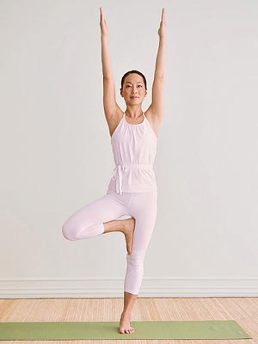Tree Pose
- Stand with arms at sides.
- Shift weight onto left leg and place sole of right foot inside left thigh, keeping hips facing forward.
- Once balanced, bring hands in front of you in prayer position, palms together.
- On an inhalation, extend arms over shoulders, palms separated and facing each another. Stay for 30 seconds.
- Lower and repeat on opposite side.
- Make it easier: Bring your right foot to the inside of your left ankle, keeping your toes on the floor for balance. As you get stronger and develop better balance, move your foot to the inside of your left calf.
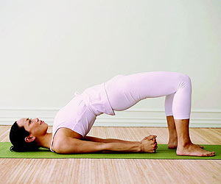Bridge Pose
Stretches chest and thighs; extends spine
- Lie on floor with knees bent and directly over heels.
- Place arms at sides, palms down. Exhale, then press feet into floor as you lift hips.
- Clasp hands under lower back and press arms down, lifting hips until thighs are parallel to floor, bringing chest toward chin. Hold for 1 minute.
- Make it easier: Place a stack of pillows underneath your tailbone.
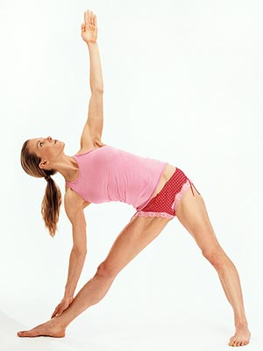Triangle Pose
- Extend arms out to sides, then bend over your right leg.
- Stand with feet about 3 feet apart, toes on your right foot turned out to 90 degrees, left foot to 45 degrees.
- Allow your right hand to touch the floor or rest on your right leg below or above the knee, and extend the fingertips of your left hand toward the ceiling.
- Turn your gaze toward the ceiling, and hold for 5 breaths.
- Stand and repeat on opposite side.
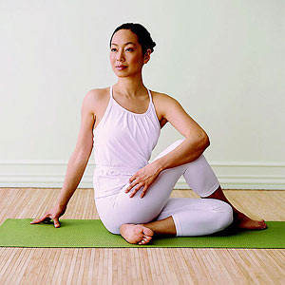Seated Twist
Stretches shoulders, hips, and back; increases circulation; tones abdomen; strengthens obliques
- Sit on the floor with your legs extended.
- Cross right foot over outside of left thigh; bend left knee. Keep right knee pointed toward ceiling.
- Place left elbow to the outside of right knee and right hand on the floor behind you.
- Twist right as far as you can, moving from your abdomen; keep both sides of your butt on the floor. Stay for 1 minute.
- Switch sides and repeat.
- Make it easier: Keep bottom leg straight and place both hands on raised knee. If your lower back rounds forward, sit on a folded blanket.
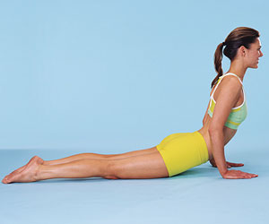Cobra
- Lie facedown on the floor with thumbs directly under shoulders, legs extended with the tops of your feet on the floor.
- Tighten your pelvic floor, and tuck hips downward as you squeeze your glutes.
- Press shoulders down and away from ears.
- Push through your thumbs and index fingers as you raise your chest toward the wall in front of you.
- Relax and repeat.
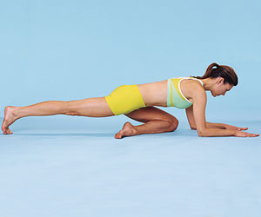Pigeon Pose
Targets the piriformis (a deep gluteal muscle)
- Begin in a full push-up position, palms aligned under shoulders.
- Place left knee on the floor near shoulder with left heel by right hip.
- Lower down to forearms and bring right leg down with the top of the foot on the floor (not shown).
- Keep chest lifted to the wall in front of you, gazing down.
- If you're more flexible, bring chest down to floor and extend arms in front of you.
- Pull navel in toward spine and tighten your pelvic-floor muscles; contract right side of glutes.
- Curl right toes under while pressing ball of foot into the floor, pushing through your heel.
- Bend knee to floor and release; do 5 reps total, then switch sides and repeat.
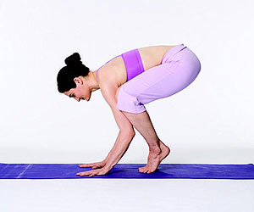Crow Pose
- Get into downward dog position (palms pressed into mat, feet hip-width apart) and walk feet forward until knees touch your arms.
- Bend your elbows, lift heels off floor, and rest knees against the outside of your upper arms. Keep toes on floor, abs engaged and legs pressed against arms. Hold for 5 to 10 breaths.
- Ready for more? Take the Crow Pose to the next level
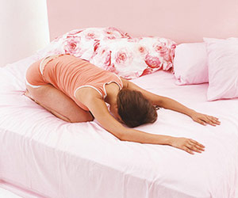Child's Pose
- Sit up comfortably on your heels.
- Roll your torso forward, bringing your forehead to rest on the bed in front of you.
- Lower your chest as close to your knees as you comfortably can, extending your arms in front of you.
- Hold the pose and breathe.

