Boxing 101
Boxing is a great workout, perhaps the most challenging of all sports. Requires speed, agility, finesse, power, endurance, and ultimate mental toughness. Boxing pushes you like no other, pitting the finest and highest level athletes against each other. More importantly boxing takes you further than you ever thought possible. Boxing makes you more alive than ever, more humble in defeat, and most glorious in victory. Boxing reveals the true fighter deep inside every single one of us.

Basic Boxing Technique

Basic Boxing Stance
The basic boxing stance is supposed to be easy for beginners to attack and defend easily. You’re well covered in this stance with both hands ready to attack easily. More advanced fighters will use different boxing stances for more advanced body movements and counter-punching opportunities.
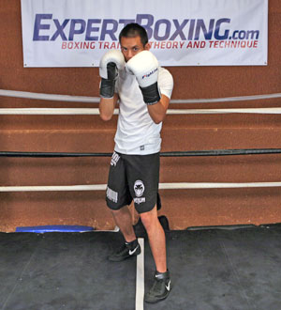
The proper boxing stance – ready to attack or defend.
- Front toe & back heel on the center line. Dominant hand in back (if you are right-handed, put the right hand in back).
- Weight evenly distributed across both legs, knees slightly bent.
- Feet diagonal, little wider than shoulder width apart, back heel raised.
- Elbows down, hands up.
- Head behind your gloves, chin slightly down, eyes see over the gloves.
- Relax and breathe!
*** Get used to returning to this position after all boxing movements!

Basic Boxing Footwork
Beginners absolutely need to master the step-drag and pivot maneuvers. This type of movement may seem difficult at first because many people have a habit of always jumping off the ground. In boxing, you want to keep your feet down on the ground so you’re always ready to attack, defend, or move away. Also, jumping around is a huge waste of energy. The flashy footwork will come naturally once you develop better conditioning and technique.
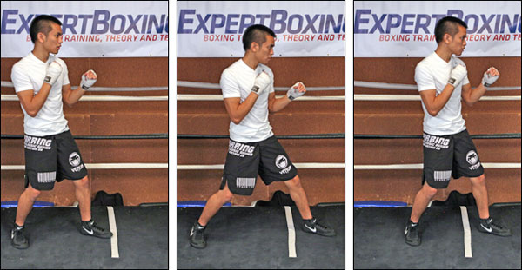
The basic STEP-DRAG
That right there is the basic boxing footwork. Step with the lead foot and drag the rear foot. This stepping and dragging boxing footwork technique ensures that your weight is grounded and always ready to attack or defend. It also prevents you from walking or crossing your feet which can make you fall off balance.
- To go FORWARD or LEFT, step with your left foot first and then drag the right foot after.
- To go BACKWARD or RIGHT, step with your right foot first and then drag the left foot after.
*** TIP: try to finish all steps with your feet at the same distance.
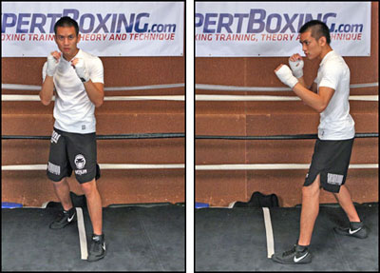
The PIVOT
The next most important boxing footwork technique you’ll need is the pivot. It’s usually done by pivoting off your front foot. You can use it defensively to avoid attacks, or offensively to find new punching angles. A pivot can be useful for counter-punching by taking you out of harm’s way and still keep you in range to throw counter punches.
- Pivot CLOCKWISE by swinging your right foot and letting your body pivot over the left foot.
- Practice small pivots (45-90 degrees) as well as big pivots (90-180 degrees).

Basic Boxing Punches
Basic Punching Technique
- Start from a relaxed position
- Exhale as you throw the punch
- Tighten your fist and body muscles at impact
- Release your hand back to you
Throwing punches is simply the act of being relaxed, then quickly accelerating your hand towards the target as you exhale sharply. You tighten your fist at the moment of impact and then relax the hand to throw more punches. The trick is to utilize your entire body weight behind the punch without falling off balance. Skills and experience will teach you over time.
For a beginner, the most important thing is to learn the proper punching form. Later on, you will be able to throw many different variations of punches from different positions and develop your own punching technique to fit your style.
Basic Punching Tips
- Turn your whole body and pivot your feet on ALL PUNCHES EXCEPT THE JAB
- Maintain your stance and balance for better power and mobility.
- make sure the non-punching hand is defending the other side of your body
- exhale sharply on every shot
- All boxing punches are basically a variation of straight punches (elbow straight), hook punches (elbow sideways), or uppercut punches (elbow down).
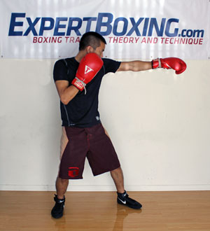
Left Straight (JAB) – the #1 most important weapon in boxing
Keeping the rest of your body still, extend your left fist straight forward.
- Exhale sharply as you punch, rotating the fist to land with the palm down.
- Pull the hand back immediately after impact to defend.
*** Try throwing a jab with a forward step. Also try a jab to the body by bending your knees & waist slightly as you jab.
The jab is the most important punch in boxing. It can attack, defend, counter, score points, make space, and many other things. It’s your longest, fastest punch, uses the least energy, and leaves you the least vulnerable. A boxing trainer will usually tell you that every combo must start with the jab. It’s a fast punch that stuns your opponent just long enough for the big punches to land. Great fighters have great jabs.
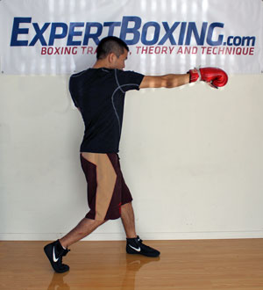
Right Straight (RIGHT CROSS) – your strongest punch
Rotate your hips and upper body CCW as you pivot your right foot (about 90 degrees).
- Exhale sharply as you extend your right fist straight out from your chin.
- Rotate the fist to land with your palm down.
- Do not let your head lean past your front knee.
*** When necessary, the right elbow can bend to create a slight looping angle (overhand right) or even a wide looping angle (hayemaker) to come around your opponent’s guard. Many boxing trainers stress the importance of a straight right for beginners because it telegraphs less and doesn’t leave the fighter as open. It’s uncommon to see a “right hook” because it would likely be blocked by their opponent’s left shoulder. Bend your knees and waist if you want to throw a cross to the body.
The right cross will naturally be your strongest punch because it comes from your dominant hand and gets leverage easily from the back. When combined, the jab and right cross become known as the basic but incredibly useful 1-2 combination.
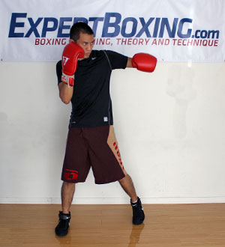
LEFT HOOK – a dangerous power punch
- Pivot your feet clockwise (about 90 degrees) as you drop the right heel and lift the left heel.
- Your body rotates as one solid block when you pivot your feet.
- The left arm tightens as you swing your left fist into the target.
*** For a left hook to the body, leave your left hand down and throw with a vertical fist.
The left hook is easily one of the deadliest punches in boxing. It comes from a side angle making it tricky to defend when an opponent is expecting straight punches. It’s also common for knockouts because the punch turns the head and easily makes opponents dizzy. You can throw left hooks to the head with your fist horizontal or vertical; for a beginner, I recommend you to use the ones that feels most natural.
Left hooks to the body are the most common way to attack the body. The “liver shot” (located under your right ribs) is known to be incredibly painful and has led to many body shot knockouts. Body shots typically take the wind out of you and kill your legs, hampering your ability to move. A well-placed body shot can momentarily paralyze your legs and keep you from standing even if you’re conscious and still willing to fight.
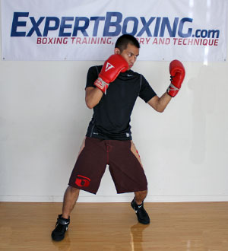
LEFT UPPERCUT – dangerous short to long-range punch
Pivot your feet clockwise (about 90 degrees) as you drop the right heel and lift the left heel.
- Your body rotates just like a left hook (don’t lean forward or backward).
- With your elbow pointing down, drop your left fist slightly and swing it upwards as you exhale.
- The punch lands with the palm facing up.
- Keep this punch compact, and recover to your stance quickly.
*** You can throw this punch more straight or more curved, and to the head or body.
The left uppercut is a great punch to use on the inside or even mid-range. It’s more powerful than the jab, comes fast, and can be quite unexpected. The only risk is that you have to be closer to your opponent and your left shoulder is not up to defend against your opponent’s rights.
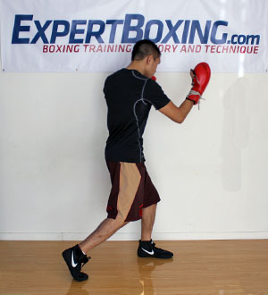
RIGHT UPPERCUT – dangerous short to long-range punch
Rotate your hips and upper body CCW as you pivot your right foot (about 90 degrees).
- Your body rotates just like a right cross (don’t lean forward or backward).
- With your elbow pointing down, drop your right fist slightly and swing it upwards as you exhale.
- The punch lands with the palm facing up.
- Keep this punch compact, and recover to your stance quickly.
The right uppercut is a devastating punch to use at close range or mid-range. It’s very powerful to throw at the head or body. The greatest risk is that you’re dropping your right hand and exposing yourself to a counter left hook.
Basic Punch Combinations
Basic punch combinations for beginners! Learn the punch numbering system below and then try out all the basic combinations. You can throw these combinations in shadowboxing, on the bags, the mitts, or even in sparring. Every seasoned boxer will have mastered these combinations as second nature.
1 = jab 2 = right cross 3 = left hook 4 = overhand right 5 = left uppercut 6 = right upper-cut b = body
*** Example: 1-2-3b combo would mean a jab to the head, then right cross to the head, then left hook to the body.
Common Boxing Combinations
- 1-1 , 1-1b, 1-2,1-2b, 1b-2,1-1-2, 1-2-1-1, 1-2-3, 1-2-1-2,1-2-3-2, 1-2-3b-2, 1-2-5-2, 1-6-3-2, 1-2-3-2-1
There’s no rule to boxing combinations. You can throw whatever punches you want in whatever order you want. There are definitely SOME guidelines, such as throwing fast feeler punches (like the jab) before you commit to the hard shots that leave you open longer. It’s also more natural to alternate punches between your right and left hand but also a good idea to throw double lefts and double rights to confuse your opponent. You’ll eventually learn other combinations later and ultimately make up your own to fit the situation.

Basic Boxing Defense
There many kinds of defensive techniques you may have heard of out there, some fancier than others. The first thing a beginner boxer needs to learn is how to block. Blocking is the easiest way to stay in punching range without getting hurt. And for beginners, blocking is the safest way because it closes off the punching angles. Once you’ve mastered blocking, then you can move on to the more advanced stuff like parrying, rolling, and slipping. The main benefits of more advanced defense techniques is that they allow you to defend yourself without using your hands, this way your hands are free to punch back!
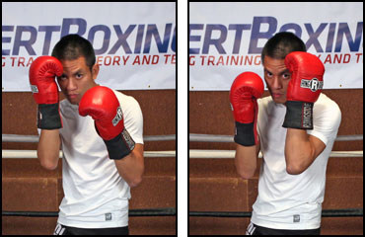
Blocking head punches
- bring your gloves closer to cover your face
- raise right glove to block left-handed punches
- raise left glove to block right-handed punches
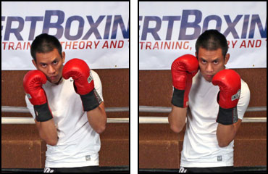
Blocking body punches
- bring your elbows closer to you
- lower the right elbow block left-handed punches
- lower the left elbow to block right-handed punches
Boxing Defense Tips
- It’s safer to cover yourself, instead of chasing the punch (which still leaves you open).
- Keep your eyes on opponent (the punches you see don’t hurt you as much).
- Stay balanced, it’s easier to block punches without getting pushed back when you’re standing on both legs.
- Fight back, the only way to go from defensive to offensive is to punch back.
- Step back, moving out of range is the easiest way to avoid all punches.
- Watch for the strong hand, if you can’t defend everything at least watch for the big punches.
Of course, there is more to blocking than simply bringing your gloves to you but this is a good start for beginners. No need to do anything fancy, or get confused about where to place your hand. Pull your hands to your face, or pull your elbows to your body.

Basic Boxing Counter-Punching
You’ll eventually realize that boxing is almost always non-stop counter-punching. You will always be attacking and defending simultaneously so you will need to combine your offensive and defensive boxing skills. For a beginner, this easiest way to counter is to block first and then counter immediately after. Jabs can be countered by simultaneously throwing another punch, or blocking first and then countering.
As your skills improve, you’ll eventually learn that any punch can be countered with any punch. The tricky part is figuring out how. For now, you should focus on the easier counters for beginners that don’t require high-level defensive movements.
Basic Counters to the Jab
- throw your own jab (head or body)
- throw another punch (head or body)
- blocking first and then countering after might not be fast enough to counter the jab
Basic Counters to a Right Cross/Overhand/Uppercut
- Intercept the right hand with a long jab.
- Or throw a fast left hook before or after your opponent’s right.
- Block first, then throw your own right hand.
Basic Counters to a Left Hook/Uppercut
- Throw a long left jab.
- Block first, then throw a counter right.

Basic Boxing Training
The best way to get trained for boxing is to enter a real boxing gym full of licensed boxing trainers and competing amateur and professional boxers. There you would only have to follow instructions from the more experienced guys and eventually customize routines to fit your needs. Now if these options aren’t available to you, here’s what I would recommend.

Essential Boxing Equipment
These are the absolute essentials EVERY BOXER needs to have. Sure you can borrow, but its gross/un-hygienic and not as safe as having your own.
Hand Wraps
Hand Wraps is a crucial tool for protecting your hands. Do not go around punching a heavy bag without hand protection, as this will likely screw up your wrist and injure you quickly. You should be wearing hand wraps everytime that you plan to put on boxing gloves. Having your own hand wraps is like having your own socks. It will be filled with your sweat and your nasty odor. You can get away with one pair but it’s probably better to cycle between 2 or 3 pairs depending on how often you train.
Gloves
Using the community gym gloves might be ok for a while but you’ll eventually fall in love with your favorite pair.. At which point, you’ll realize it’s best to have your own training gloves, because it smells better, has newer padding, and always available when you need it.
If you could only have one pair, get 16oz training gloves. If you can afford to have a second pair, get 12oz or 14oz for when you want to do some speed work on the heavy bag or double-end bag. (For sparring, always use 16oz.) Smaller guys, women, or kids (below 120lbs) can train with 14oz gloves or less but otherwise I highly recommend the 16oz standard.
Mouthguard
This is a must if you’re going to do any sparring. I don’t know why there are still idiots out there who think it’s ok to spar without mouthguard. Possible consequences: A) you lose a tooth because the impact lands perfectly on one tooth instead of dispersing itself over your jaw. B) You injure your jaw (making you weak-chinned for a long time) because the lower jaw swings freely and isn’t secured against the upper jaw. Higher likelihood of concussion for you. C) You bite your tongue. I’ve actually bitten STRAIGHT THROUGH my tongue once. Imagine how painful it is to give yourself a tongue piercing with your own teeth.
Don’t share a mouthpiece either. Unless it’s molded to your teeth, it won’t give you the maximum amount of protection. Also, people bleed on their mouthpieces all the time and you might get someone else’s disease (i.e. hepatitis, aids, herpes, etc). The best mouthguards cost at least $20 but anything is better than nothing.
Headgear
You’ll eventually want your own headgear if you’re going to do regular sparring. It’ll fit you better and always be available instead of always being used or draped with somebody else’s sweat. The padding will be a lot better since it’s not being used by 30 other people. Headgear is ALWAYS a must when you’re sparring; don’t go without it.
Boxing Shoes
Boxing shoes increase your mobility and power in the ring. This is due to their superior grip and slim material which increases your agility. You’ll not only feel better but move a whole lot better. There is no other equipment that can improve your boxing ability faster than simply putting on a pair of boxing shoes. My favorite brands are Nike and Adidas. Everlast and Rival are also ok. Title, I don’t like so much.
Gym & Trainer
The fastest way to learn is to learn from somebody who knows what he’s doing. The people and environment you surround yourself with have a great effect on your self-growth. Training with trainers and better fighters will improve your skill level quickly. Training by yourself or with lower level fighters will slow your progress. With that said, being in a gym and working with a trainer is the best way to go. It will be tough and scary and out of your comfort zone but it will make you a better fighter!
Partner
A partner can hold mitts for you, spar with you, run with you, train with you, motivate you and push you beyond your limits. Boxing, like many other endeavors, is a thousand times more fun when done with others. Trying to box without a partner is like learning how to play chess all by yourself. You’d be imagining all sorts of irrelevant possibilities only to lose later when you finally face a live opponent. If you don’t like taking forever, get a partner so you can progress exponentially.
Heavy Bag
For a beginner, you’ll need the heavy bag to develop your punching form, punching power, punching speed, and punching endurance. It will probably be tons of fun for you at first because you’ve never had a chance to exert all your energy like that. Eventually you’ll move on to bigger and better things but for a beginner, the heavy bag is plenty of fun.
Jump-rope
For $5, you can’t find a better piece of boxing equipment that will help develop your overall boxing conditioning, balance, footwork, and even punching abilities. The jump rope is a common way to warm-up, workout, or warm down for boxers.
Speed-bag
Great for developing rhythm, timing, accuracy, hand speed, and arm endurance. The speed bag is absolutely crucial for serious boxers but not truly necessary for recreational ones. If you have access to one, great.
Boxing ring
You can spar anywhere but a boxing ring is best if you want to learn how to box according to the common rules and scenarios of boxing. Having a ring helps limit the area so neither you or your opponent can run out of range. It also forces you to develop long range as well as close range fighting skills. On a more psychological level, being in a ring forces you to confront your opponent without any option to quit.

Boxing Workout
Below is a general idea of a basic boxing workout. It might be too easy for the natural athletes but also too hard for others. Do what you can and work your way up. If something feels hard to do, then you know you need to do it more. If something hurts, STOP. Last but not least, TAKE YOUR REST. Don’t be a noob and train until you’re completely sore and injured. No intelligent athlete does that, only noobs (because they don’t know how to be productive other than to completely exhaust themselves).
Boxing Warm-up
- 3 ROUNDS – run or jump rope (both are good, too).
- 3 ROUNDS – shadowbox.
- Stretch and move around to warm-up the body.
Boxing Workout
- 3 ROUNDS – focus mitts with trainer/partner (to develop new skills)
- 3 ROUNDS – heavy bag
- 3 ROUNDS – speed bag
- 3 ROUNDS – double end bag
- 3 ROUNDS – more shadowboxing (to reinforce new learned skills and warm-up for sparring)
- 3 ROUNDS – sparring, can be for training or learning purposes [sparring link]
- 3 ROUNDS – conditioning work, can be plyometrics, tabata drills, resistance training, calisthenics, etc
Boxing Warm-down
- 100 push-ups
- 100 sit-ups
- 100 crunches
- stretch again so you don’t get too sore or cramped for the next day
Boxing Training Tips:
- Ask for tips from everybody. it’s amazing what you’ll learn when you get advice from many different angles – there is more than one way to do things, you must learn them all (there is no “best way”)
- Eat right. It will give you more energy and speed up your recovery.

Basic Boxing Strategy

Boxing is 90% Mental Strength
Once it comes time to competing whether in the gym or a tournament, you’re bound to run into confidence issues at some point or another. It’s natural for people to start doubting themselves at their first major failure. You start to wonder if boxing is even for you. Or maybe you feel like you’ve reached a plateau and can’t get any better. Here are some guides to help you overcome these mental challenges.

Beginner Boxing Mistakes More beginner boxing tips!
Beginner Technique Mistakes
- Letting the head lean past the knees.
- Having a tight body and tight fists when not punching.
- Letting your feet lift when you punch (decreases balance, grounding and power).
- Covering the eyes when defending.
- Having too much ego. Make sure you ask for tips from everybody. It’s amazing what you’ll learn when you get advice from many different angles – there is more than one way to do things, you must learn them all (there is no “best way”).
Beginner Training Mistakes
- Not having a good trainer, thinking you can learn everything on your own.
- Too much heavy bag.
- Focusing too much on power (instead of speed, endurance, balance, accuracy, etc).
- Not enough shadowboxing.
- Not taking rest days during the week.
- Responsive training (sparring, mitts) is far more beneficial than drill training (shadowboxing, bagwork, etc).
Beginner Fighting Mistakes
- Dropping your hands.
- Jumping around instead of using the step-drag.
- Not looking at the opponent (especially during exchanges).
- Throwing too little or too many punches, the best combos are thrown 3-5 punches at a time.
- Reaching with punches instead of waiting until you’re in range.
- Not using the jab regularly.

