8-Minute Workout: Pilates for a Longer, Leaner Look
This express Pilates workout will help you tone your core and improve your posture.
Pilates does more than just tone and firm your core. By initiating all movements from your center, you'll improve your posture and look leaner in just a few workouts. To maximize results, keep your belly button drawn in and up, your neck and back long, and your shoulders relaxed. Do this routine daily to keep your body looking its best.

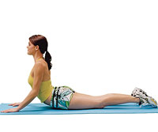

Minutes 0:00-1:00: Swan
Targets: Back, Abdominals, Inner Thighs
- Lie facedown on the floor, legs together, palms on floor by shoulders, elbows at sides.
- Press hands into floor and inhale, lifting head, shoulders, and chest.
- Arch upper back slightly, keeping abs drawn in.
- Take 2 or 3 breaths.
- Slowly return head and chest to floor.
- Repeat.

Double-Leg Stretch
Minutes 1:00-2:00
Targets: Abdominals, Inner Thighs
- Lie on back, hugging knees into chest.
- Curl head, neck, and shoulders off floor.
- Extend arms overhead next to ears; simultaneously lift legs 45 degrees.
- Hold for 1 count, then bend knees, circling arms out to sides to return hands to shins.
- Repeat, keeping upper body lifted and inner thighs pressed together.

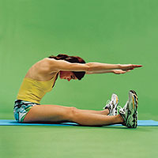

Spine Stretch Forward
Minutes 2:00-4:00
Targets: Back, Abdominals
- Sit with arms and legs extended.
- Inhale and sit up tall; exhale and reach forward over legs.
- Curl head, neck, and shoulders forward, scooping navel toward spine. (Think of bending over a beach ball, not bending at the waist.)
- Inhale; hold for 1 count.
- Exhale; deepen abdominal scoop.
- Inhale, rolling up to sit.
- Repeat.

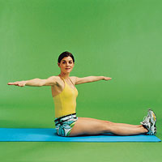

Seated Spine Twist
Minutes 4:00-6:00
Targets: Obliques
- Sit with legs extended, feet flexed, arms extended at sides at shoulder level.
- Inhale and sit up tall, then exhale and draw your abs in, twisting at the waist to the right.
- Rotate rib cage, arms, and head, keeping hips square.
- Inhale and return to face front.
- Repeat to the left, then continue to alternate sides.

Leg Pull Front
Minutes 6:00-7:00
Targets: Abdominals, Back, Quads
- Sit with legs extended, hands on floor, fingers pointing toward body.
- Lift hips off floor to bring body into a straight line.
- Raise left leg as high as you can without shifting hips.
- Hold for 3 seconds, then slowly lower leg to floor.
- Alternate sides.

Leg Pull Back
Minutes 7:00-8:00
Targets: Abdominals, Glutes, Hamstrings, Chest (not shown)
- Start out in a full push-up position with your abdominals engaged, hands in line with shoulders.
- Lift left leg 2 to 5 inches off the floor.
- Point toes and hold for 3 full seconds before slowly lowering your leg.
- Repeat with right leg; continue to alternate sides.

