HIV Overview

HIV/AIDS: The Basics
(Last updated 9/27/2013; last reviewed 9/27/2013)

Key Points
- HIV is the virus that causes HIV infection. AIDS is the most advanced stage of HIV infection.
- HIV is spread through contact with the blood, semen, vaginal fluids, or breast milk of a person infected with HIV. The most common ways HIV is transmitted are through anal or vaginal sex and sharing of drug injection equipment with a person infected with HIV.
- The treatment for HIV infection is called antiretroviral therapy (ART). ART involves taking a combination of HIV medicines (called an HIV regimen) every day.
- ART can’t cure HIV infection, but it can help people infected with HIV live longer, healthier lives.

What is HIV?
HIV stands for human immunodeficiency virus. HIV is the virus that causes HIV infection. HIV attacks and destroys the infection-fighting CD4 cells of the immune system. Loss of CD4 cells makes it difficult for the body to fight infections and certain cancers.

What is AIDS?
AIDS stands for acquired immunodeficiency syndrome. AIDS is the most advanced stage of HIV infection.

How is HIV spread?
HIV is spread through the blood, semen, vaginal fluids, or breast milk of a person infected with HIV. The spread of HIV from person to person is called HIV transmission.
The most common ways HIV is transmitted are through anal, oral, or vaginal sex and sharing of drug injection equipment with a person infected with HIV.
HIV can pass from an HIV-infected woman to her child during pregnancy or childbirth, or by breastfeeding. This spread of HIV is called mother-to-child transmission of HIV.
You can’t get HIV by shaking hands or hugging a person infected with HIV. And you can’t get HIV from contact with objects such as dishes, toilet seats, or doorknobs used by a person with HIV.

What is the treatment for HIV?
The treatment for HIV infection is called antiretroviral therapy (ART). ART involves taking a combination of HIV medicines (called an HIV regimen) every day. (HIV medicines are often called antiretrovirals or ARVs.) ART prevents HIV from multiplying and destroying infection-fighting CD4 cells, which helps the body fight off infections and certain cancers. ART can prevent HIV infection from advancing to AIDS.
ART can’t cure HIV, but it can help people infected with HIV live longer, healthier lives. By reducing the amount of HIV in the body, ART also reduces the risk of HIV transmission.

What are the symptoms of HIV/AIDS?
The first signs of HIV infection may be flu-like symptoms, such as fever, headache, and rash. The symptoms may come and go for a month or two after infection. After this earliest stage of HIV infection, more severe symptoms of HIV infection generally don’t appear for many years.
HIV transmission is possible at any stage of HIV infection—even if a person infected with the virus has no symptoms of HIV.

How long does it take for HIV infection to advance to AIDS?
Without treatment, HIV can advance to AIDS. The time it takes for HIV to advance to AIDS varies, but it can take 10 years or more.
The following criteria are used to determine if a person with HIV has AIDS:
- A CD4 count of less than 200 cells/mm³. A CD4 count measures the number of CD4 cells in a sample of blood. The CD4 count of a healthy person ranges from 500 to 1,200 cells/mm³.
OR
- An AIDS-defining condition. AIDS-defining conditions include opportunistic infections and cancers that are life-threatening in a person with HIV.
1.) Acute HIV Infection
Acute HIV infection is the earliest stage of HIV. Acute HIV infection can occur within 2 to 4 weeks after a person is infected with HIV. In some people, this stage of HIV infection can take up to 3 months to develop. During acute HIV infection, many people have flu-like symptoms, such as fever, headache, and rash. In the acute stage of infection, HIV multiplies rapidly and spreads throughout the body. The virus attacks and destroys the infection-fighting CD4 cells of the immune system. HIV can be transmitted during any stage of infection, but the risk is greatest during acute HIV infection.
2.) Chronic HIV Infection
The second stage of HIV infection is chronic HIV infection (also called asymptomatic HIV infection or clinical latency.) During this stage of the disease, HIV continues to multiply in the body but at very low levels. People with chronic HIV infection may not have any HIV-related symptoms, but they can still spread HIV to others. Chronic HIV infection can last up to 10 years or longer.
3.) AIDS
AIDS is the final stage of HIV infection. Because HIV has destroyed the immune system, the body can’t fight off opportunistic infections and cancer. (Examples of opportunistic infections include pneumonia and tuberculosis.) AIDS is diagnosed when a person with HIV has a CD4 count of less than 200 cells/mm³ and/or one or more opportunistic infections. Without treatment, people with AIDS typically survive about 3 years.

What is HIV testing?
HIV testing shows if a person is infected with HIV. HIV is the virus that causes AIDS. AIDS is the most advanced stage of HIV infection.
HIV testing can detect HIV infection but it can’t tell how long a person has been HIV infected or if the person has AIDS.

Why is HIV testing important?
HIV testing helps protect your health. Whether testing shows you are HIV-negative or HIV-positive, you can take steps to protect your health.
If you are HIV-negative:
Testing shows that you don’t have HIV. Continue taking steps to avoid getting HIV, such as using a condom during sex. For more information read the AIDSinfo fact sheet on HIV prevention.
If you are HIV-positive:
Testing shows that you are infected with HIV, but you can still take steps to protect your health. Begin by talking to your health care provider about antiretroviral therapy (ART). ART is the use of HIV medicines to treat HIV infection. ART involves taking a combination of HIV medicines every day. ART helps people with HIV live longer, healthier lives. ART also reduces the risk of sexual transmission of HIV. Your health care provider will help you decide when to start treatment and what HIV medicines to take.

Who should get tested for HIV?
The Centers for Disease Control and Prevention (CDC) recommends HIV testing for everyone 13 to 64 years old as part of routine medical care.
CDC recommends HIV testing at least once a year for people at high risk of HIV infection. Factors that increase the risk of HIV infection include:
- Having unprotected sex (sex without using a condom) with someone who is HIV-positive or whose HIV status is unknown
- Having sex with many partners
- Exchanging sex for money or drugs
- Having a sexually transmitted disease (STD), such as syphilis
- Using drugs with needles and sharing needles, syringes, or other drug equipment (“works”) with others
Talk to your health care provider about your risk of HIV infection and a testing schedule that suits you.

Should pregnant women get tested for HIV?
CDC also recommends that all pregnant women get tested for HIV. Women who test HIV positive take HIV medicines during pregnancy and childbirth to reduce the risk of mother-to-child transmission of HIV. Babies born to HIV-infected women receive HIV medicines for 6 weeks after birth to reduce the risk of mother-to-child transmission of HIV.
Because HIV can be transmitted in breast milk, HIV-infected women in the United States should not breastfeed their babies. In the United States, baby formula is a safe and healthy alternative to breast milk.

What are the types of HIV tests?
The three main HIV tests are the HIV antibody test, the HIV RNA test, and the Western blot test.
HIV antibody test
The HIV antibody test is the most common HIV test. The test checks for HIV antibodies in blood, urine, or fluids from the mouth. HIV antibodies are a type of protein the body produces in response to HIV infection.
Once a person is infected with HIV, it generally takes about 3 months for the body to produce enough antibodies to be detected by an HIV antibody test. (For some people, it can take up to 6 months.) This time period between infection with HIV and the appearance of detectable HIV antibodies is called the window period. During the window period, the level of antibodies in the body is too low to be detected by an HIV antibody test. For this reason, the HIV antibody test isn’t used during the window period.
It usually takes a few days to a few weeks to get results of an HIV antibody test. Some rapid HIV antibody tests can produce results within 30 minutes.
HIV RNA test
An HIV RNA test can detect HIV in a person’s blood within 9 to 11 days after the person is infected with HIV—before the body has produced enough antibodies to be detected by an HIV antibody test.
The HIV RNA test is used during the window period when recent infection is suspected—for example, soon after a person has had unprotected sex with a partner infected with HIV. Immediately after infection, the amount of HIV in the body is very high, which increases the risk of HIV transmission. Detecting HIV at the earliest stage of infection lets a person take steps right away to prevent spreading HIV to others. This includes the option to start taking HIV medicines.
Results from an HIV RNA test are usually available within a few days to a few weeks.
Western blot test
HIV is diagnosed on the basis of positive results from two HIV tests. The first test can be either an HIV antibody test (using blood, urine, or fluids from the mouth) or an HIV RNA test (using blood). A positive result on a first HIV test must be confirmed by a second HIV test (always using blood). The confirmatory test typically used is a different type of antibody test called a Western blot test.
Results from a Western blot test are usually available within a few days to a few weeks. A positive Western blot test result confirms that a person is infected with HIV.

Is there an HIV test for home use?
There are two HIV tests approved by the U.S. Food and Drug Administration (FDA) for home use. One test involves collecting a blood sample at home and then sending the sample to a lab for testing. The person using the test must wait about 1 week before calling the lab to get the test results.
The other approved home use test doesn’t depend on a lab for test results. Using the test involves swabbing the gums with a test device to get a sample of oral fluids and then inserting the test device into a test solution. Test results are ready in 20 to 40 minutes.
A positive result on a home HIV test must always be confirmed by a Western blot test done in a health care setting.
Learn more about HIV home test kits approved by FDA.

Is HIV testing confidential?
If you get tested at a doctor’s office or clinic, you can ask for a confidential HIV test. This means that only people allowed to see your medical records will see your test results. If your HIV test results show that you are infected with HIV, this information may be reported to your state health department to be counted in statistical reports. Your name will not be attached to the information.
Some states have “anonymous” testing, which means you don’t have to give your name when you take an HIV test. When you take the test, you receive a number. To get your test results, you give the number instead of your name.

What are the stages of the HIV life cycle?
To understand the HIV life cycle, it helps to first imagine what HIV looks like.
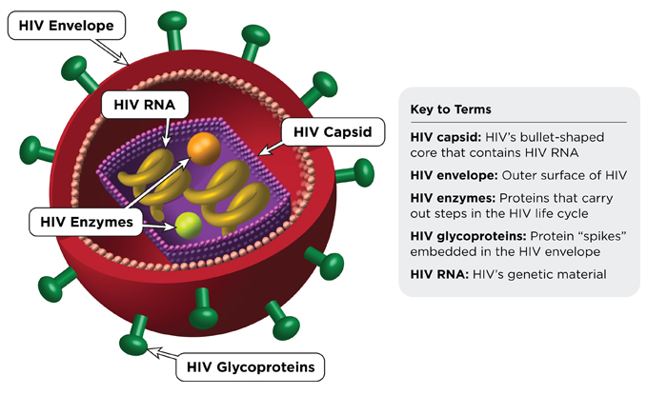
Now you are ready to follow HIV as it attacks a CD4 cell. The image below shows each stage of the HIV life cycle.
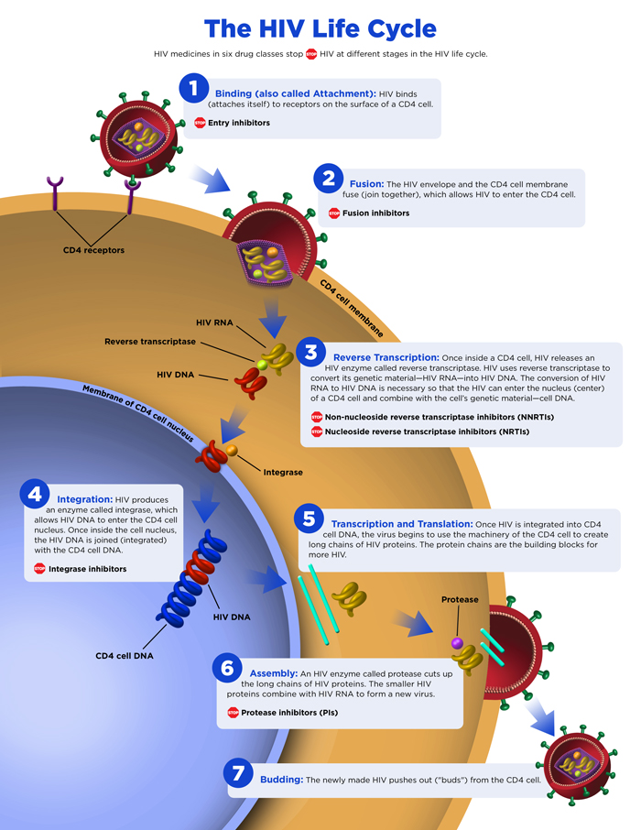

How can I learn more about the HIV life cycle?
Learn more from the following sources of information. This fact sheet is based on information from these sources.

