My One Month Personal Fitness Plan:
Volleyball Conditioning

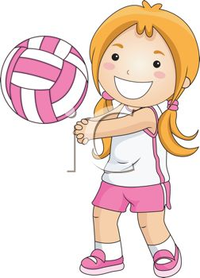
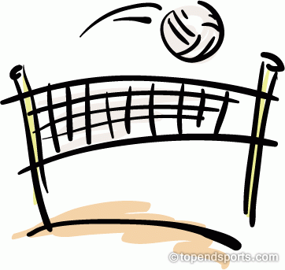

Samantha Hoff
Ms. McLean
Fitness for Life – 6th Hour
June 2, 2014

My Personal Fitness Goal
My personal fitness goal is to condition for the volleyball season. The reason I choose this goal is because volleyball tryouts are in a couple weeks and in the summer I’m trying out for a select level volleyball team at Michigan Elite so I want to make sure I’m ready for it. Also, when I am older I want to get into Michigan State University and I want to try and get an athletic scholarship if I can.

In my plan I will have drills and exercises to help my reaction time to quickly move off court to get a volleyed ball and get the ball faster when it is spiked to me. Second, upper body and lower body strength to help me become a better hitter and server. Third, increase my flexibility to improve my jumping abilities. Fourth, improve my endurance by staying in the ready position longer. Last, improve my cardiovascular endurance to last 5 games in a match or an all-day tournament. I feel some of my skills aren’t to their full potential yet so I plan to work on them in my fitness plan.

My fitness plan will benefit me by improving all these skills of volleyball and hopefully for now get me on to a select level team at Michigan Elite. It will condition and prepare me for my future volleyball goal of making the team. This is the reason why I choose volleyball to be the basis of my fitness plan.

