CORE TRAINING
16 STATIONS

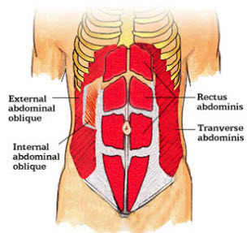

GRISSOM MIDDLE SCHOOL
PHYSICAL EDUCATION
FITNESS FOR LIFE
MS. MCLEAN

CORE TRAINING
Six-pack, eight-pack, washboard, whatever you want to call it, your core is the centerpiece for any muscular physique. It is the eye-catcher for the opposite sex.
A muscular and well-defined core shows both strength and health. Both guys and gals strive to have a strong, toned midsection, but very few of them ever achieve getting one. If you have been looking for the perfect program to get you the tight, strong core you always looked for, look no farther.
The core is composed of four different parts. Below, I will discuss where each is located, what its function is in the body, and also a couple exercises you can do to stimulate the muscle.

Abdominals
Rectus Abdominus:
- Location: Covers the front area from sternum all the way down to the pelvis bone. Often referred to as the six-pack.
- Function: Pulls the upper torso to the hips
- Exercises: Crunches or Sit-up, Flutter Kicks, Superman,
Oblique:
- Location: Side of the waist.
  - Internal Oblique’s-located under the external oblique’s, running in the opposite direction.
  - Transverse Oblique’s-located under the oblique’s it is the deepest of the abdominal muscles and wraps around your spine for protection and stability.
  - External Oblique’s-located on the side and front of the abdomen.
- Function: Tilt and twist the torso
- Exercises: Side Bends, Leg Lifts, Crunches, Russian Twist, Elbow to Knee, Reverse Crunches
Intercostals:
- Location: Between the side of the rib cage. It comes into play when you flex the torso and twist from side to side.
- Function: Elevation and depression of the ribs
- Exercise: Air Bike
Serratus:
- Location: Between front abs and lats.
- Function: Pulling of the scapula forward and around like in the motion of throwing a punch
- Exercises: Barbell Pullovers and Cable Crunches

Rep Ranges
The core is made up of primarily fast-twitch muscle fibers. Fast-twitch muscle fibers are denser than their counterparts (the slow-twitch muscle fibers). Hence, hard, heavy, and explosive bouts of exercise will stimulate fast-twitch fibers a lot more.
This means that core training should be in the moderate rep range for best growth. No more endless reps of crunches and sit-ups like you've done in the past. Focus on sets in the 8-15 rep range.

Benefits of Good Core Strength
- A Strong Core Reduces Back Pain
Abdominals get all the credit for protecting the back and being the foundation of strength, but they are only a small part of what makes up the core. In fact, it is weak and unbalanced core muscles that are linked to low back pain. Weak core muscles result in a loss of the appropriate lumbar curve and a swayback posture. Stronger, balanced core muscles help maintain appropriate posture and reduce strain on the spine.
- A Strong Core Improves Athletic Performance
Because the muscles of the trunk and torso stabilize the spine from the pelvis to the neck and shoulder, they allow the transfer of power to the arms and legs. All powerful movements originate from the center of the body out, and never from the limbs alone. Before any powerful, rapid muscle contractions can occur in the extremities, the spine must be solid and stable and the more stable the core, the most powerful the extremities can contract.
- A Strong Core Improves Postural Imbalances
Training the muscles of the core helps correct postural imbalances that can lead to injuries. The biggest benefit of core training is to develop functional fitness; the type of fitness that is essential to daily living and regular activities.

AIR BIKE
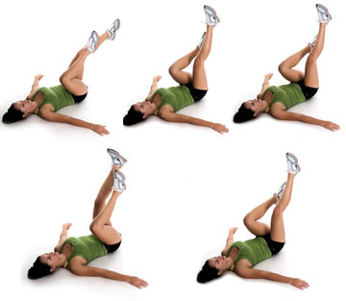

REVERSE CRUNCHES
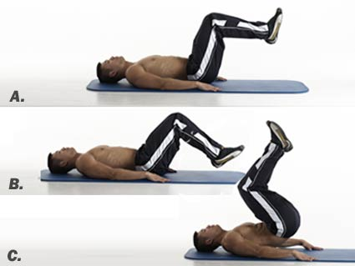

SUPERMAN
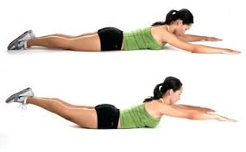
FLUTTER KICKS
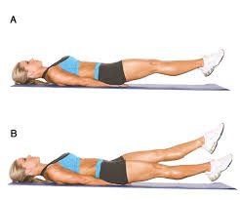

LEG LIFTS
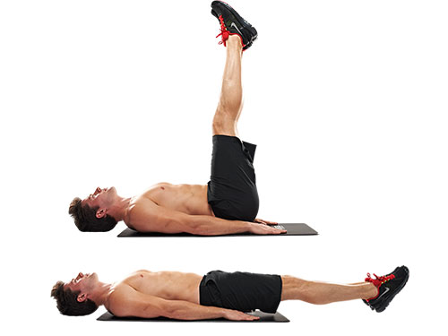
SIT UPS
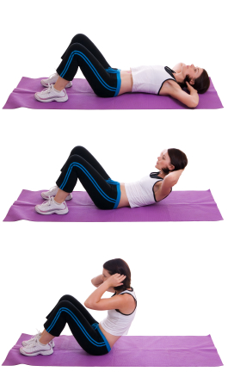
RUSSIAN TWIST
SIDE BENDS

ELBOWS TO KNEES
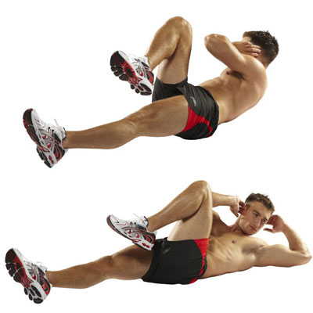

SCISSORS
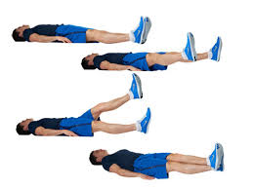
JACK KNIFE
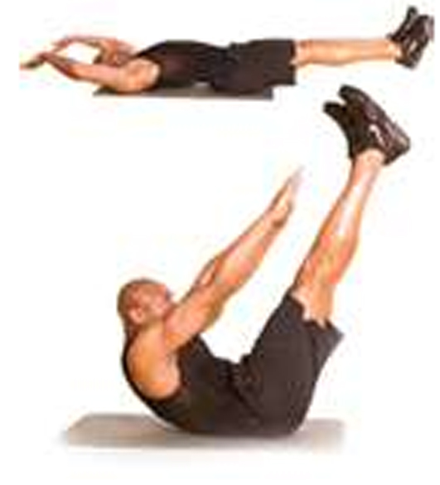
BURPEES
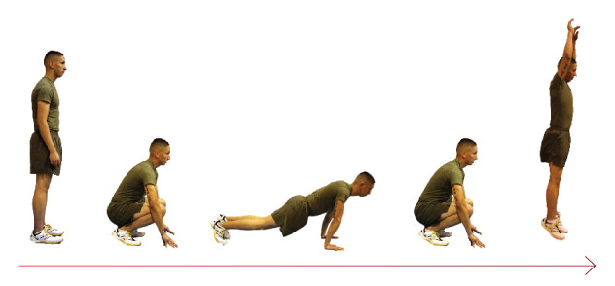

STABILITY CRUNCHES
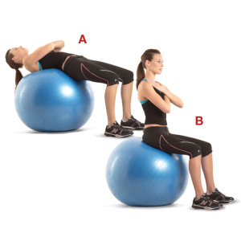
BRIDGES

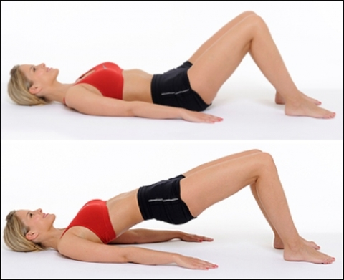
PLANKS

SIDE PLANKS

MOUNTAIN CLIMBERS

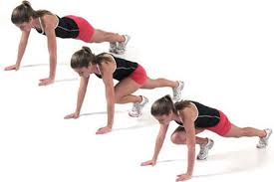
STABILITY BALL ROLL UPS
